Programming Assignment 1

Algorithms 3100

Charlie Irmiger

9/4/2020

DESCRIPTION

I wrote both the recursive Fibonacci and the good Fibonacci in Python 3. I used the methods outlined in the homework to run both functions and keep track of individual runs. I also ran 20 averages of 50 runs, since 20 and 50 were the constants used in the example. I decided to go N=35 since I was running the code on my gaming computer, which still struggled past N=30. After I printed each average, I copied the values into excel where I was able to use the AVE, STDEV.S, and CONFIDENCE.T functions to compute values from the data and write the 95% confidence interval into a table.

CODE

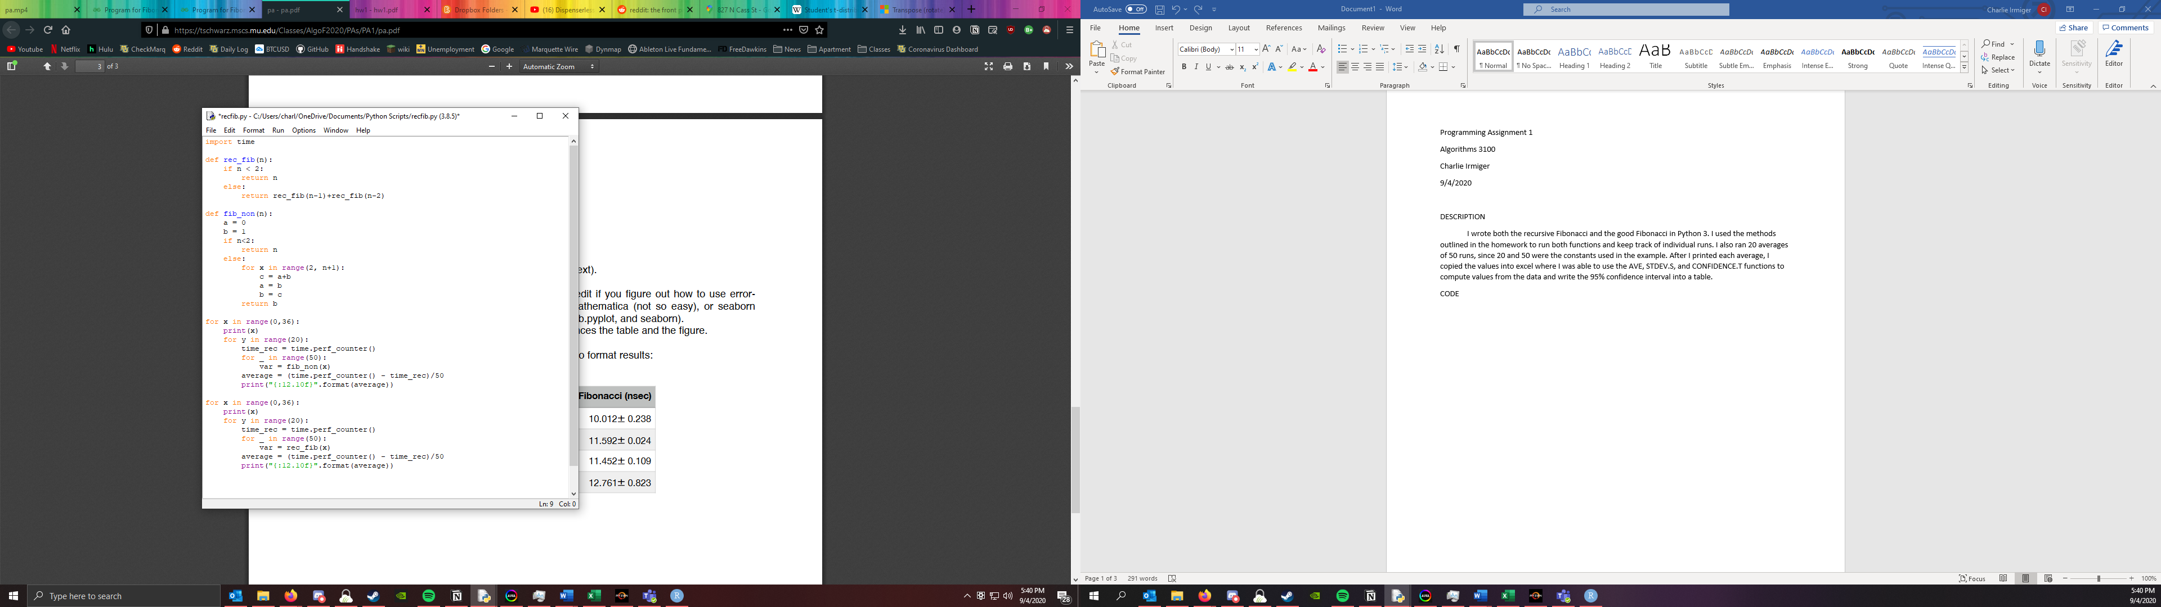

TABLE

|  |  |  |  |  |
| --- | --- | --- | --- | --- |
| Value | Recursive Fib (nsec) | ± CI (95%) | Good Fib (nsec) | ± CI (95%) |
| 0 | 0.000000199 | 1.98562E-09 | 0.000000207 | 3.309E-09 |
| 1 | 0.00000022 | 2.64749E-09 | 0.000000247 | 7.281E-09 |
| 2 | 0.000000472 | 7.94247E-09 | 0.000000582 | 1.324E-09 |
| 3 | 0.000000713 | 4.63311E-09 | 0.000000682 | 6.619E-08 |
| 4 | 0.000001155 | 2.84605E-08 | 0.000000615 | 8.604E-09 |
| 5 | 0.000001834 | 3.83886E-08 | 0.000000649 | 4.633E-09 |
| 6 | 0.000002928 | 1.58849E-08 | 0.000000694 | 2.383E-08 |
| 7 | 0.000004911 | 4.30217E-08 | 0.000000736 | 2.647E-09 |
| 8 | 0.00000769 | 7.94247E-09 | 0.000000771 | 4.633E-09 |
| 9 | 0.000012645 | 1.40979E-07 | 0.000000801 | 8.604E-09 |
| 10 | 0.000020298 | 4.23598E-08 | 0.000000841 | 4.633E-09 |
| 11 | 0.000032835 | 3.6403E-08 | 0.000000866 | 1.986E-08 |
| 12 | 0.000053095 | 1.78044E-07 | 0.000000918 | 7.942E-09 |
| 13 | 0.000087059 | 8.67715E-07 | 0.000001075 | 6.95E-08 |
| 14 | 0.00014145 | 4.14332E-07 | 0.000001037 | 2.581E-08 |
| 15 | 0.000228684 | 5.45383E-07 | 0.000001104 | 5.295E-09 |
| 16 | 0.000363629 | 3.80577E-07 | 0.000001147 | 1.986E-09 |
| 17 | 0.000587003 | 1.79434E-06 | 0.000001259 | 3.243E-08 |
| 18 | 0.001012635 | 4.16073E-05 | 0.000001256 | 9.266E-09 |
| 19 | 0.001574907 | 1.89686E-05 | 0.000001364 | 1.059E-08 |
| 20 | 0.002512187 | 1.05946E-05 | 0.000001369 | 7.281E-09 |
| 21 | 0.004243024 | 9.68994E-05 | 0.000001458 | 1.324E-09 |
| 22 | 0.006834533 | 0.000199043 | 0.000001479 | 3.111E-08 |
| 23 | 0.010479501 | 3.70318E-06 | 0.000001595 | 5.626E-08 |
| 24 | 0.017399975 | 2.28154E-05 | 0.000001627 | 6.619E-10 |
| 25 | 0.027928746 | 7.09382E-05 | 0.000001713 | 1.986E-09 |
| 26 | 0.046198047 | 0.001003267 | 0.000001788 | 1.456E-08 |
| 27 | 0.073042332 | 0.000155267 | 0.000001806 | 1.324E-08 |
| 28 | 0.121317817 | 0.001448609 | 0.000001903 | 4.435E-08 |
| 29 | 0.194411477 | 0.001869769 | 0.000001924 | 2.383E-08 |
| 30 | 0.31441215 | 0.000542971 | 0.000002034 | 6.619E-09 |
| 31 | 0.506933695 | 0.002646092 | 0.000002083 | 3.309E-09 |
| 32 | 0.804398731 | 0.005597905 | 0.000002203 | 6.685E-08 |
| 33 | 1.282648325 | 0.000418709 | 0.000002317 | 5.494E-08 |
| 34 | 2.114878104 | 0.021583907 | 0.000002261 | 2.052E-08 |
| 35 | 3.458022703 | 0.00927125 | 0.000002329 | 3.508E-08 |

CONCLUSION

What I concluded from my data and statistical processing is conformation that the good Fibonacci is much more efficient than recursive Fibonacci. This is especially true once N starts to go past 25. The recursive Fibonacci sequence is clearly of time complexity O(n2 ) whereas the good Fibonacci is of time O(n). These results are especially clear in the graphs, where the good fib appears linear and the recursive fib is clearly exponential.